**Given the provided data, what are three conclusions that we can draw about crowdfunding campaigns?**

In the category summary, the chart shows that the success rate for categories Theater, Music and Film& Video where beyond reach compared to the remaining six categories. Theater was more successful but in percentage wise it was below both film&video and music because of the high-level number for both canceled and failed outcomes recorded.



The second conclusion has to do with the subcategory confirming theater domination. This is because the subcategory PLAY has the most successful outcome compared to the other two categories music and film&video. However, its cancelation and fails outcomes outweighs it to fall below music and film&audio.



The last conclusion has to do with launch date and the success for the categories. February through April had a terrible decline because of canceled and failed outcomes. However, the growth rate was indicated from the month of May through July because of highest number of successful campaigns. It is paramount to note that there was a decline of success in the month of December because of increase in cancelled and failed outcomes in December.

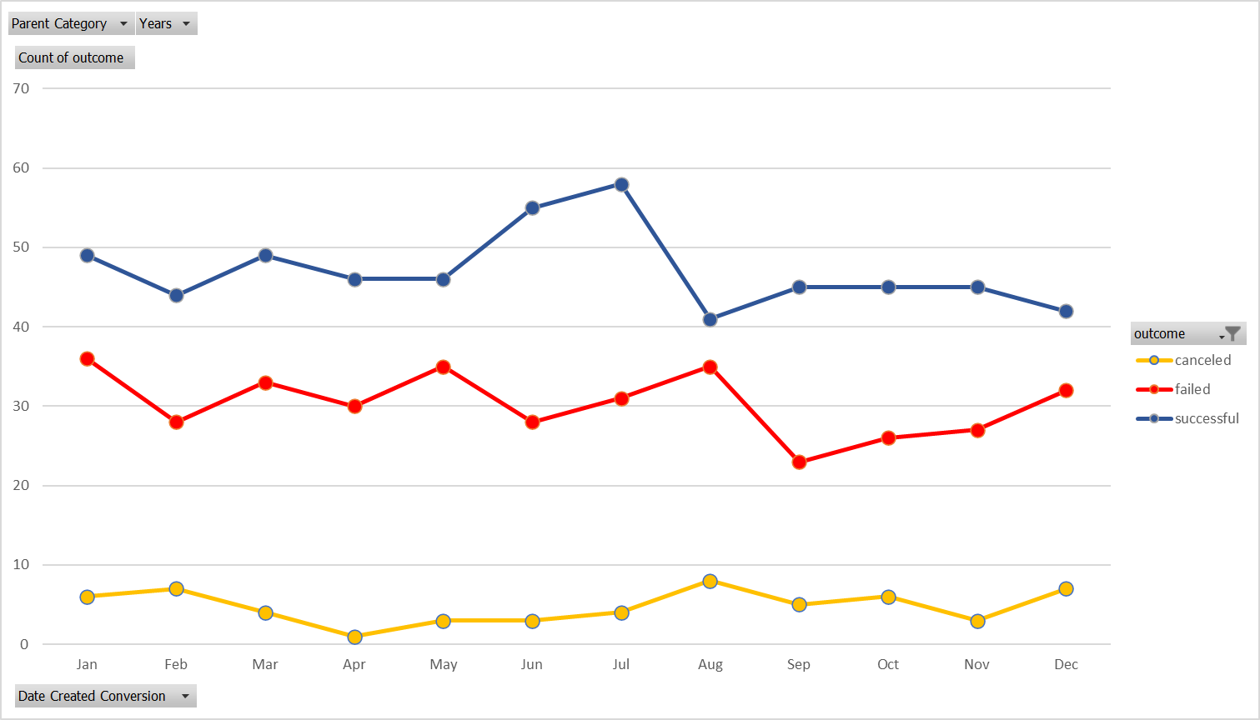

**What are some limitations of this dataset?**

There should have been a data quantifying the category and subcategory part of the dataset. That would have led to high level of granularity when analyzing the successful and unsuccessful campaigns.

Also, platforms like Kickstarter and Indiegogo have been in existence since late 2000s, and they are still currently active. It would have been statistically correct if we had worked with a 2022-2023 data set. Historically data is useful when making strategic decisions about present and future but current data helps to make the right decisions quickly.

**What are some other possible tables and/or graphs that we could create, and what additional value would they provide?**

1. We can create a table and chart to show successful and unsuccessful categories/subcategories. This will help analyzing thoroughly on how to have a successful campaign. It will reveal what not to do to avoid unsuccess.
2. Time data summary will be very useful when it comes to the duration period it can take a company to achieve funding targets for higher success.